4-H Online 2.0 Animal Entry Guide
Dog Project
*Note: For 4-H Members 8 and above

Log into 4-H Online

- Use your family email and password co.4honline.com

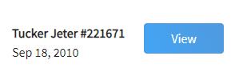
Click “View”, next to Member’s Name

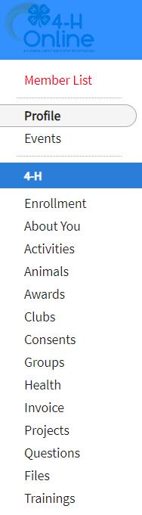
Locating ‘Animals’
- Desktop, select “Animals” from the left side navigation

- Smart Phone or Tablet, click on the 3 bars in the top left corner
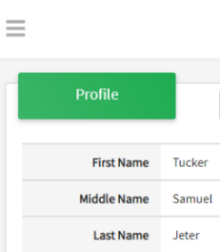
With either option, this will bring up a drop down list to begin adding Animals.

Adding an Animal
- Click "Add an Animal"
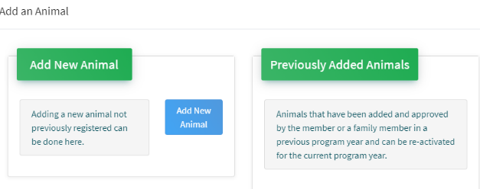Then select “Add New Animal”
- Select Dog, from the drop down. REQUIRED: Enter Animal’s name, click “Save”
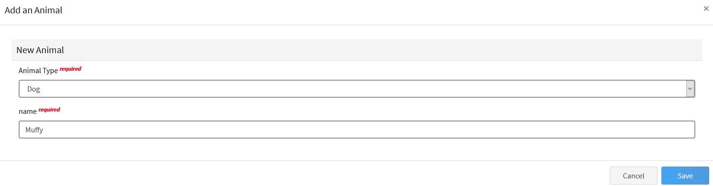
- Next, click “Show Questions”
Animal Entry is open for the current enrollment year. - Is all information complete? Check all county animal entry deadlines.
READ All County instructions for each animal species as county requirements vary.
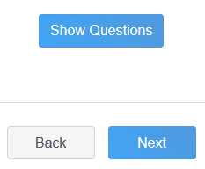
- The animal’s name will be carried over from the previous screen.
- Enter the CURRENT weight of the animal. This is for determining size of the animal.
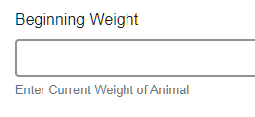
- Enter the animal’s birth date.
- Choose the breed from the drop-down box. Choose “other breed” or “mixed breed” if breed isn’t listed. ONLY select one breed.
- Fill in a description of the dog’s colors and markings.
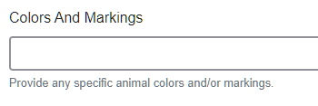
- Enter the dog’s height in inches as measured from the ground to withers (highest point of the dog’s shoulders).
- Enter whether you own the dog or are leasing it.

- Enter all vaccination information (Note: Enter Expiration dates) 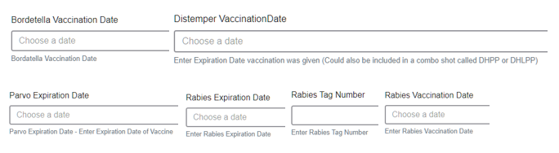
- Enter the registration information if your dog is registered.

- Enter the Animal Gender – male or female.

- Enter a Tag or Tattoo, if applicable.
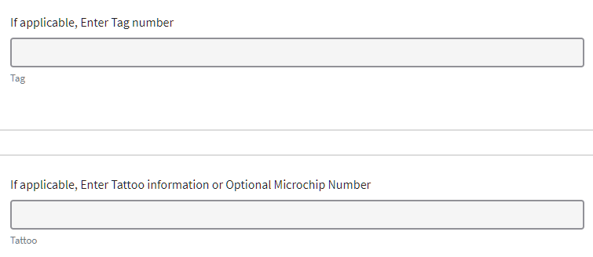
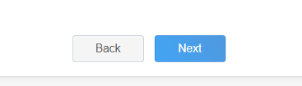
- Click “Next”, continue with the “File Uploads” that are required by your local county extension office. These will vary by county and species. Please follow your county guidelines.
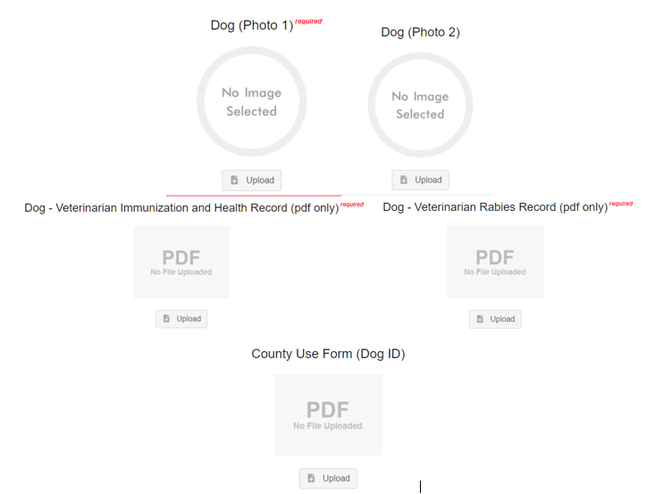
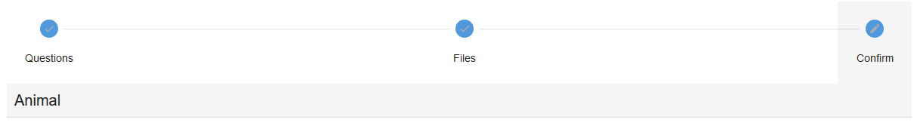
- Confirm all information, click ‘submit’
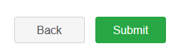
- County Extention staff, will review all information. If more is needed, members can edit. Once “Approved” by your local county extension office an email will be sent to your family account (example below) A time and date stamp for each animal.
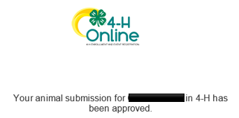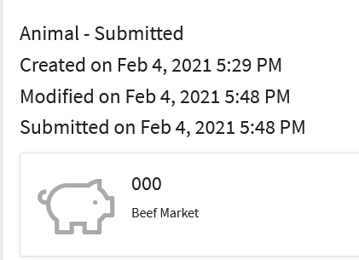
Questions, please contact your local extension staff.

